Machine Learning and Deep Learning for Loan Prediction in Banking Exploring Ensemble Methods and Data Balancing

Abstract

The prediction of loan defaults is crucial for banks and financial institutions due to its impact on earnings, and it also plays a significant role in shaping credit scores. This task is a challenging one, and as the demand for loans increases, so does the number of applications. Traditional methods of checking eligibility are time-consuming and laborious, and they may not always accurately identify suitable loan recipients. As a result, some applicants may default on their loans, causing financial losses for banks. Artificial Intelligence, using Machine Learning and Deep Learning techniques, can provide a more efficient solution. These techniques can use various classification algorithms to predict which applicants will likely be eligible for loans. This study uses five Machine Learning classification algorithms (Gaussian Naive Bayes, AdaBoost, Gradient Boosting, K Neighbors Classifier, Decision Trees, Random Forest, and Logistic Regression) and eight Deep Learning algorithms (MLP, CNN, LSTM, Transformer, GRU, Autoencoder, ResNet, and DenseNet). The use of Ensemble Methods and SMOTE with SMOTE-TOMEK Techniques also has a positive impact on the results. Four metrics are used to evaluate the effectiveness of these algorithms: accuracy, precision, recall, and F1-measure. The study found that DenseNet and ResNet were the most accurate predictive models. These findings highlight the potential of predictive modeling in identifying credit disapproval among vulnerable consumers in a sea of loan applications.

Existing System and Disadvantages
Existing loan default prediction systems primarily rely on traditional manual assessment methods or basic statistical models to evaluate applicants’ creditworthiness. These approaches are slow, labor-intensive, and often inaccurate in handling large volumes of applications, which increases the risk of approving loans for individuals who may default, causing financial losses for banks.
Disadvantages:
- Subjectivity and Inefficiency: The manual, human-based credit assessment process can be subjective and is highly time-consuming, leading to delays in loan approvals.
- Limited Data Analysis: Traditional methods struggle to analyze the vast and complex datasets available today, missing crucial patterns and correlations that could indicate risk.
- Risk of Bias: Human-based decisions can be influenced by unconscious biases, which can lead to unfair or inconsistent outcomes.
- Imbalanced Data Challenge: The dataset of loan applications is often highly imbalanced, with a small number of defaults compared to successful loans, which can lead to models with poor predictive performance on the minority class.

Proposed System and Advantages
The proposed system uses advanced Machine Learning and Deep Learning algorithms to automate and enhance loan default prediction. By leveraging multiple ML models (like Random Forest, Gradient Boosting, and Logistic Regression) and DL models (such as DenseNet, ResNet, LSTM, and CNN) along with ensemble techniques and SMOTE-based data balancing, the system accurately identifies high-risk applicants. This approach improves prediction accuracy and speeds up the loan approval process, helping financial institutions minimize default risk and financial losses.
Advantages
- Advanced Ensemble Methods: The system will explore and implement powerful ensemble methods like Random Forest, Gradient Boosting, and others. These methods combine the predictions of multiple base models to produce a more accurate and stable final prediction.
- Effective Data Balancing: To address the issue of imbalanced data, the system will integrate data balancing techniques such as Synthetic Minority Over-sampling Technique (SMOTE), which will improve the model's ability to accurately predict loan defaults.
- Automation and Efficiency: The automated model will significantly reduce the time required for loan processing, allowing banks to handle a higher volume of applications more efficiently.
- Improved Accuracy and Risk Assessment: By analyzing a wider range of data and identifying complex patterns, the system will provide a more accurate risk assessment, helping to minimize financial losses from loan defaults.

System Architecture
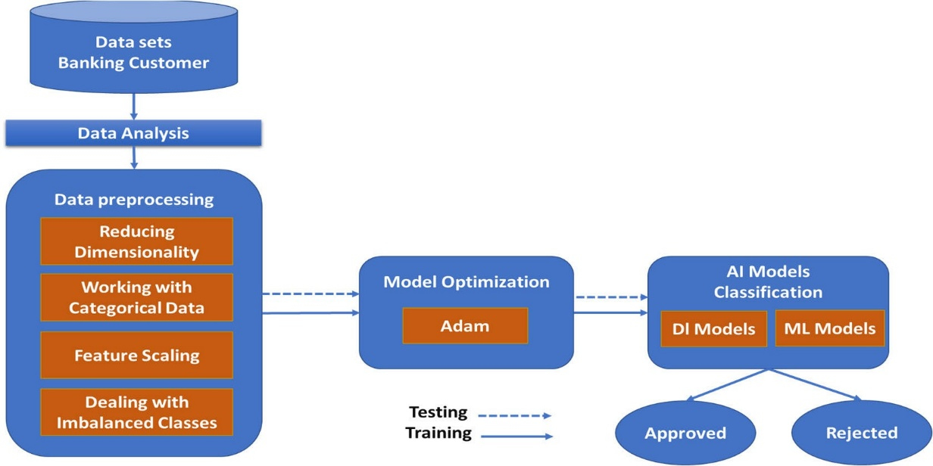
The architecture of the proposed loan prediction system is a multi-layered pipeline, from data.

Module Description
The system will be composed of the following key modules:
- Data Acquisition Module:
  - Manages the connection to the bank's data sources and handles data extraction.
- Data Cleaning and Balancing Module:
  - Implements algorithms for data cleaning, transformation, and balancing.
- Modeling Module:
  - Houses the different machine learning and deep learning algorithms.
  - Manages the training, validation, and testing phases.
- Prediction API Module:
  - A lightweight API that exposes the trained model for making real-time predictions on new loan applications.
- Dashboard Module:
  - A user-friendly interface for bank employees to view model performance metrics, reports, and individual loan predictions.

Hardware and Software Requirements
Hardware Requirements:
- Processor: A powerful CPU with multiple cores is recommended for handling complex calculations and model training.
- RAM: A minimum of 32 GB of RAM is suggested to handle large datasets efficiently.
- Storage: A high-speed SSD for quick data access.
Software Requirements:
- Operating System: Windows, macOS, or Linux.
- Programming Language: Python.
- Libraries and Frameworks:
  - Data Manipulation: Pandas and NumPy.
  - Machine Learning: Scikit-learn.
  - Deep Learning: TensorFlow or PyTorch.
  - Visualization: Matplotlib, Seaborn.
  - Web Framework: Flask or FastAPI for the prediction API.

Functional Requirement
User Module (Bank Officers / Loan Applicants / Analysts)
- Login / Registration – Secure access to the system.
- Submit Loan Application Data – Upload or enter applicant details (income, credit history, loan amount, etc.).
- Run Eligibility Check – Use ML/DL models to predict the likelihood of loan default.
- View Prediction Results – Display risk assessment, including probability of default and eligibility recommendation.
- Compare Models – Optionally view predictions from multiple algorithms (ML/DL models, Ensemble methods).
- View Metrics – See performance metrics like accuracy, precision, recall, and F1-measure for each prediction.
- Export Reports – Download prediction reports for record-keeping or review (PDF/CSV).
- Notification Alerts – Receive alerts for high-risk applicants or failed predictions.
- Provide Feedback – Submit feedback on system predictions or usability issues.
- Logout – Securely exit the system.
Admin Module (System Administrator / Data Scientist / Bank IT Staff)
- Admin Login – Secure authentication for administrators.
- User Management – Add, remove, or manage bank officers, analysts, and other users.
- Dataset Management – Upload, clean, and maintain loan application datasets for model training.
- Model Management – Train, update, and fine-tune ML/DL models (e.g., DenseNet, ResNet, Random Forest, LSTM).
- Algorithm Configuration – Set parameters for Ensemble methods, SMOTE, and SMOTE-TOMEK techniques.
- Performance Monitoring – Track model metrics such as accuracy, precision, recall, and F1-score.
- System Monitoring – Monitor server status, processing times, and resource utilization.
- Report Generation – Generate system-wide reports on predictions, applicant risk, and model performance.
- Alerts & Notifications – Configure system alerts for high-risk cases or model errors.
- Security & Backup – Ensure secure storage of applicant data, maintain privacy compliance, and perform regular backups.

